**Introduction to Database (Mid-term Assignment)**

**Project Name: Cineplex Management System**

**Group- TEAM TRIO**

**Group Members:**

|  |  |
| --- | --- |
| **Name** | **Id** |
| **KABIR, MD. TAJIMUL** | **19-40419-1** |
| **SAYEM, EASINUL ABEDIN** | **19-40291-1** |
| **RAHMAN ARIAN** | **19-39515-1** |

**Scenario:**

Star Cineplex is the first multiplex cinema theatre in Bangladesh.Star Cineplex has a strong management for maintaining the whole system. A Manager has M_ID, M_name, M_address, M_phone, M_email. In Cineplex management system there are many employees who controlled by the manager. The attributes of employees include E_ID, E_name, E_address, E_phone, E_mail, E_salary, E_age.Manager manages all employees. Tickets is must needed for watching a show in cineplex. Few employees sell ticket in ticket booth or people can buy tickets from online by visiting cineplex official website. A Ticket has T_ID, T_name, T_price. One ticket can be sold from only one show. Show has some attributes include S_id,S_name, S_date, Start_ time, End _time. One show will run at a time. One manager can manage many employees.

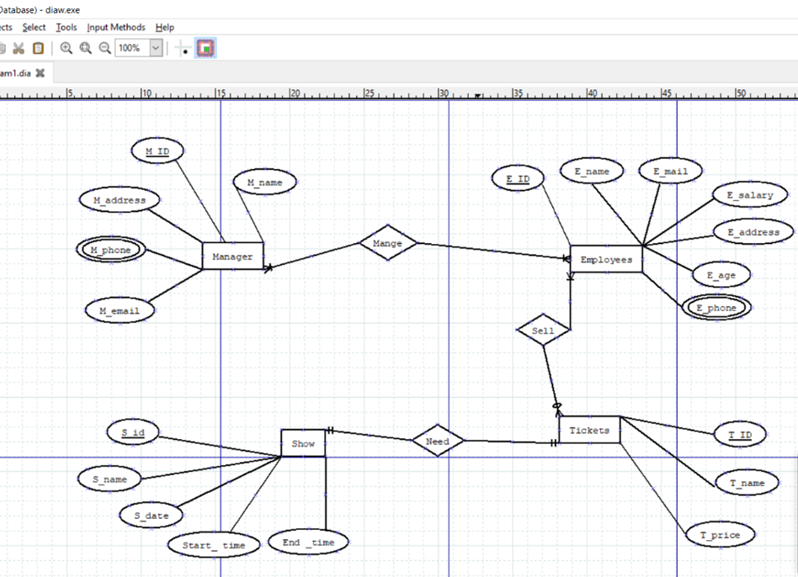

NORMALIZATION:

Manage (M_id,M_name,M_address,M_phone,M_email,E_id,E_name,E_mail,E_salary,E_address,

E _age ,E_ phone)

**1NF:**

M_ phone & E_ phone -> multivalued attributes

**2NF:**

M_ID, M_ name, M_ address, M_ phone, M_ email

E_ id, E_ name, E_ mail, E_ salary, E_ address ,E_ age, E_ phone

**3NF:**

M_ID, M_ name, M_ address, M_ phone, M_ email

E_ id ,E_ name, E_ mail, E_ salary, E_ address ,E_ age, E_ phone

No transitive dependency.

**Table:**

M_ ID,M_ name ,M_ address ,M_ phone, M_ email

E id ,E_ name, E_ mail, E_ salary, E_ address ,E_ age, E_ phone

Sell (E_id,E_name,E_mail,E_salary,E_address,E_age,E_phone,T_id,T_name,T_price)

**1NF:**

E_ phone -> multivalued attribute.

**2NF:**

E_ id, E_ name, E_ mail, E_ salary, E_ address ,E_ age, E_ phone

T_id, T_ name,T_ price

**3NF:**

E_id,E_name,E_mail,E_salary,E_address,E_age,E_phone

T_id,T_name,T_price

No transitive dependency.

Table:

E_id,E_name,E_mail,E_salary,E_address,E_age,E_phone

T_id,T_name,T_price

Need (T_id,T_name,T_price,S_id,S_name,Start_time,End_time)

**1NF:**

No multivalued attributes

**2NF:**

T_id,T_name,T_price,S_id

S_id,S_name,Start_time,End_time

**3NF:**

T_id,T_name,T_price,S_id

S_id,S_name,Start_time,End_time

No transitive dependency

Table:

T_id,T_name,T_price,S_id

S_id,S_name,Start_time,End_time

Total Table:

M_ID,M_name,M_address,M_phone,M_email

E_id,E_name,E_mail,E_salary,E_address,E_age,E_phone

T_id,T_name,T_price

T_id,T_name,T_price,S_id

S_id,S_name,Start_time,End_time

Final Table:

1st. M_ID,M_name,M_address,M_phone,M_email

2nd. E_id,E_name,E_mail,E_salary,E_address,E_age,E_phone

3rd. T_id,T_name,T_price

4th. T_id,T_name,T_price,S_id

5th. S_id,S_name,Start_time,End_time

Table with constraint

Create table Manager (M_id number(6) Constraint Manager_M_id_PK Primary key,M_name varchar2(25) not null,M_address varchar2(35) not null,M_phone number(11) unique,M_email varchar2(20) unique)

` 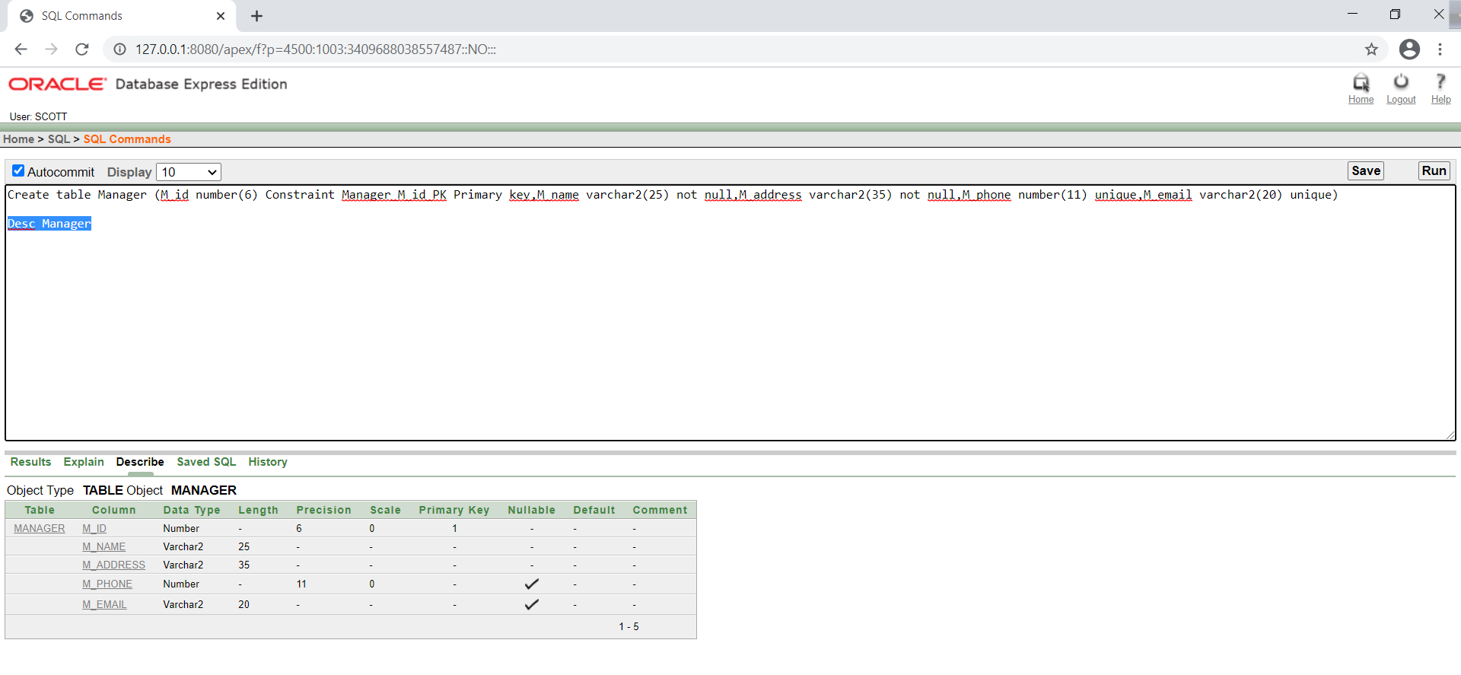

Create Table Employee(E_id number(6) Constraints Employee_E_id_PK primary key,E_name varchar2(25) default 'No name',E_email varchar2(20) unique,E_salary number(7) check (E_salary>0),E_address varchar2(35) not null,E_age number(2) check (E_age>16),E_phone number(11) unique)

Desc Employee

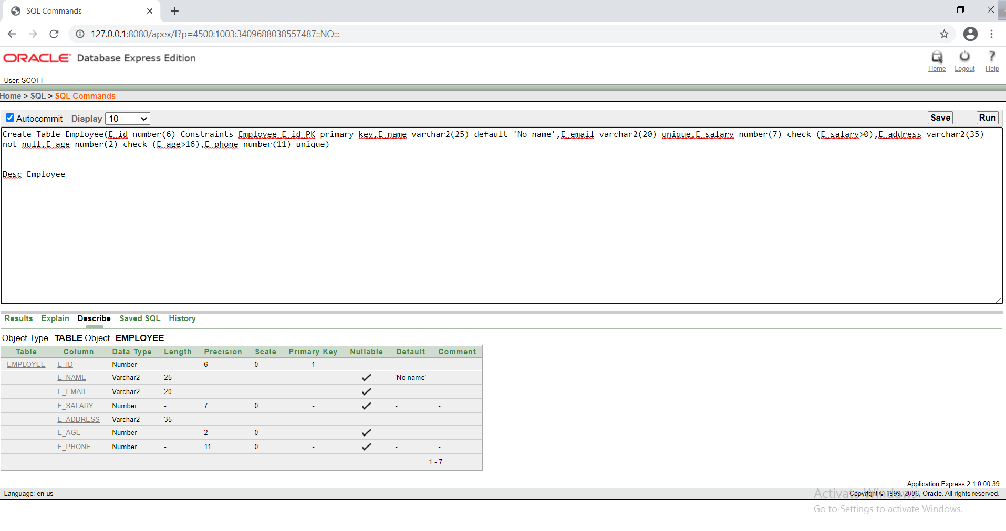

Create table Tickets(T_id number(4) Constraints Tickets_T_id_PK primary key,T_name varchar2(15) default 'No name',T_price number(4) check (T_price>300))

Desc Tickets

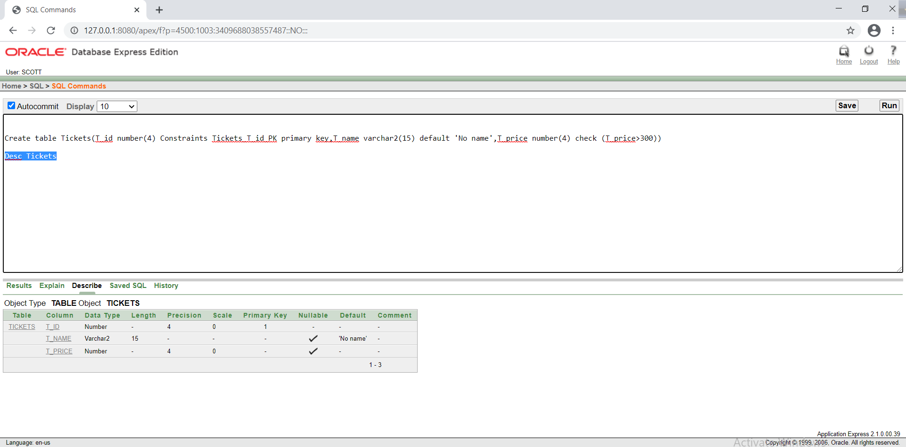

Create Table Shows(S_id number(3) Constraints Shows_S_id_PK primary key,S_name varchar2(15) default 'No name',Start_time varchar2(6) not null,End_time Varchar2(6) not null)

Desc Shows

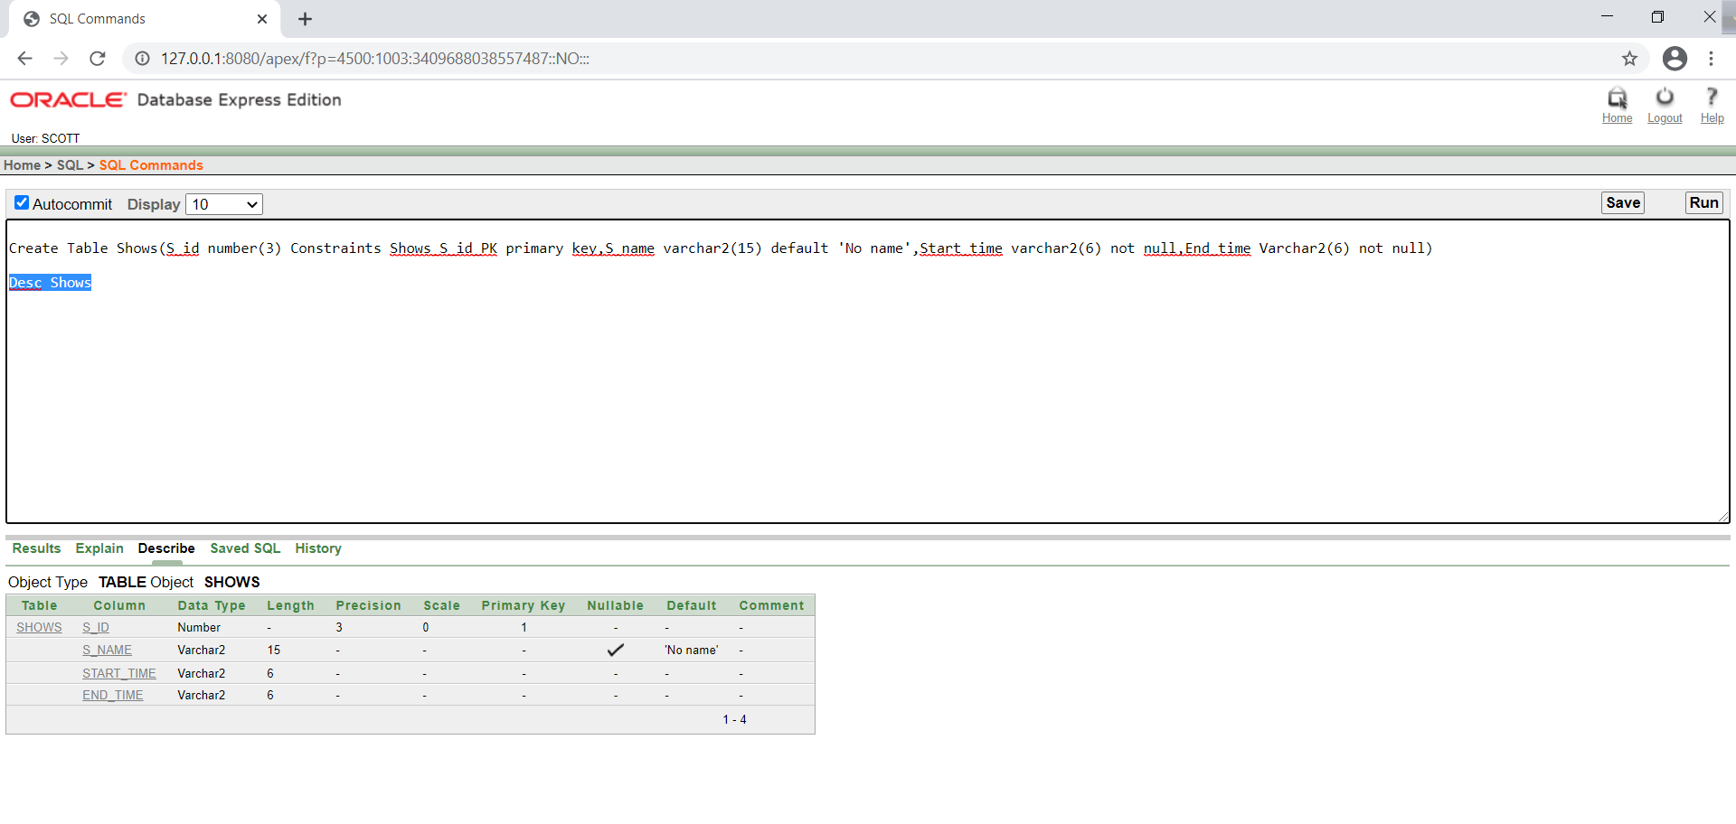

Create table Ticket_show(T_id number(4) Constraints Ticket_show_T_id_PK primary key,T_name varchar2(15) default 'No name',T_price number(4) check (T_price>300),S_id number(3) Constraint Tickekt_show_S_id_FK references SHows(S_id))

Desc Ticket_show

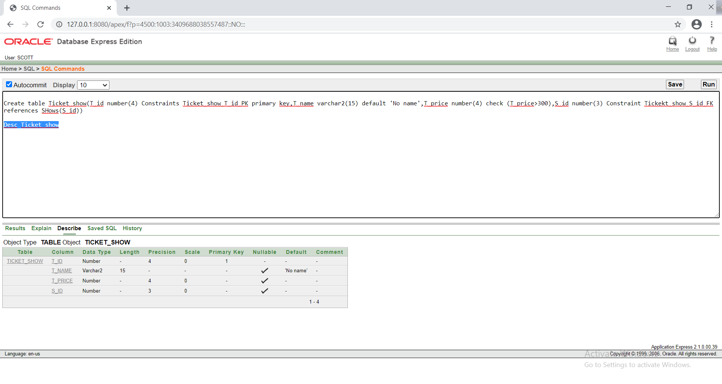

5. Data insert

For Manager Table:

Insert into Manager(M_id,M_name,M_address,M_phone,M_email)values(1,'SAKIB

Hasan','UTTARA-10,Dhaka',11726425894,'sakibhasan@gmail.com')

Insert into Manager(M_id,M_name,M_address,M_phone,M_email)values(2,'NOWAZ

Hasan','UTTARA-11,Dhaka',11348565894,'nowaz23@gmail.com')

Insert into Manager(M_id,M_name,M_address,M_phone,M_email)values(3,'FOYSAL

ISLAM','MOTIHJIL-2,Dhaka',51700123894,'FS03@gmail.com')

Insert into Manager(M_id,M_name,M_address,M_phone,M_email)values(4,'NIAZ

Rahman','Dhanmondi-10,Dhaka',41935478294,'niaz23@gmail.com')

Insert into Manager(M_id,M_name,M_address,M_phone,M_email)values(5,'RUMMAN

Zaman','CANTONMENT,Dhaka',61621594242,'rumman23@gmail.com')

Insert into Manager(M_id,M_name,M_address,M_phone,M_email)values(6,'NIHAD

UDDIN','KAFRUL,Dhaka',28309817234,'nihad23@gmail.com')

Insert into Manager(M_id,M_name,M_address,M_phone,M_email)values(7,'ABDULLAH

HASAN','BANANI,Dhaka',97999991222,'abdullah04@yahoo.com')

Insert into Manager(M_id,M_name,M_address,M_phone,M_email)values(8,'Ahmed

ZUBAIR','Mirpur-14,Dhaka',09827635235,'ahzub797@gmail.com')

Insert into Manager(M_id,M_name,M_address,M_phone,M_email)values(9,'SEHIRUL

ISLAM','PALTAN,Dhaka',09361729387,'sehirul23@gmail.com')

Insert into Manager(M_id,M_name,M_address,M_phone,M_email)values(10,'ZIBON MAHMUD','GULSHAN-4,Dhaka',03972165387,'zibon23@gmail.com')

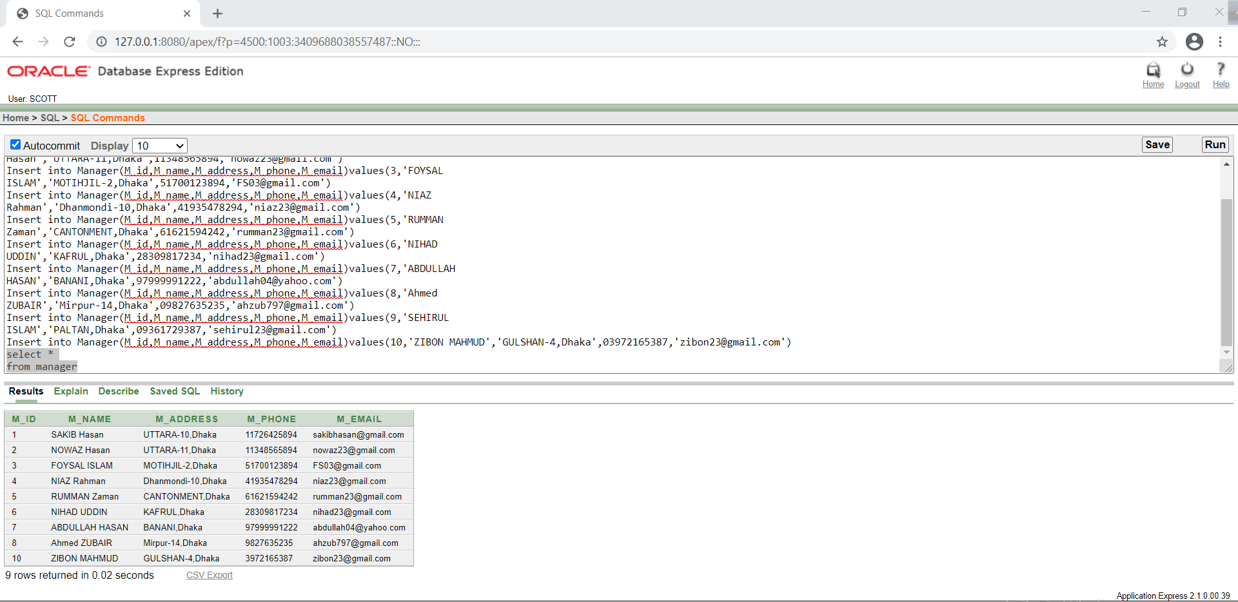

FOR EMP

TABLE

Insert into Employee(E_id,E_name,E_email,E_salary,E_address,E_age,E_phone)Values(101,'Zamil',

'zamil@gmail.com',4500,'Uttara-3,Dhaka',17,092718238121)

Insert into Employee(E_id,E_name,E_email,E_salary,E_address,E_age,E_phone)Values(102,'Rakib',

'rakib3452@gmail.com',4500,'Nilkhelt,Dhaka',18,09281673615)

Insert into Employee(E_id,E_name,E_email,E_salary,E_address,E_age,E_phone)Values(103,'Sakib',

'sakib66@yahoo.com',4200,'Panthapoth,Dhaka',20,09327125634)

Insert into Employee(E_id,E_name,E_email,E_salary,E_address,E_age,E_phone)Values(104,'Jisan',

'jissan33@gmail.com',4000,'Gulsan,Dhaka',22,39123102934)

Insert into Employee(E_id,E_name,E_email,E_salary,E_address,E_age,E_phone)Values(105,'Rakin',

'rakin27@gmail.com',5000,'Bananni,Dhaka',17,039182763152)

Insert into Employee(E_id,E_name,E_email,E_salary,E_address,E_age,E_phone)Values(106,'Turjo',

'turjo44@gmail.com',4800,'Kuratoli,Dhka',18,05123452013)

Insert into Employee(E_id,E_name,E_email,E_salary,E_address,E_age,E_phone)Values(107,'Rouf',

'rouf78@gmail.com',3500,'Mirpur,Dhaka',24,041278310238)

Insert into Employee(E_id,E_name,E_email,E_salary,E_address,E_age,E_phone)Values(108,'Tutol',

'tutol44@gmail.com',4800,'Zatrabari,Dhaka',20,02123419231)

Insert into Employee(E_id,E_name,E_email,E_salary,E_address,E_age,E_phone)Values(109,'Shuvro',

'shu44@gmail.com',4700,'Bananni,Dhaka',20,19203123410)

Insert into Employee(E_id,E_name,E_email,E_salary,E_address,E_age,E_phone)Values(110,'Rifat',

'rifat99@gmail.com',5000,'Mirpur,Dhaka',22,09183721234)

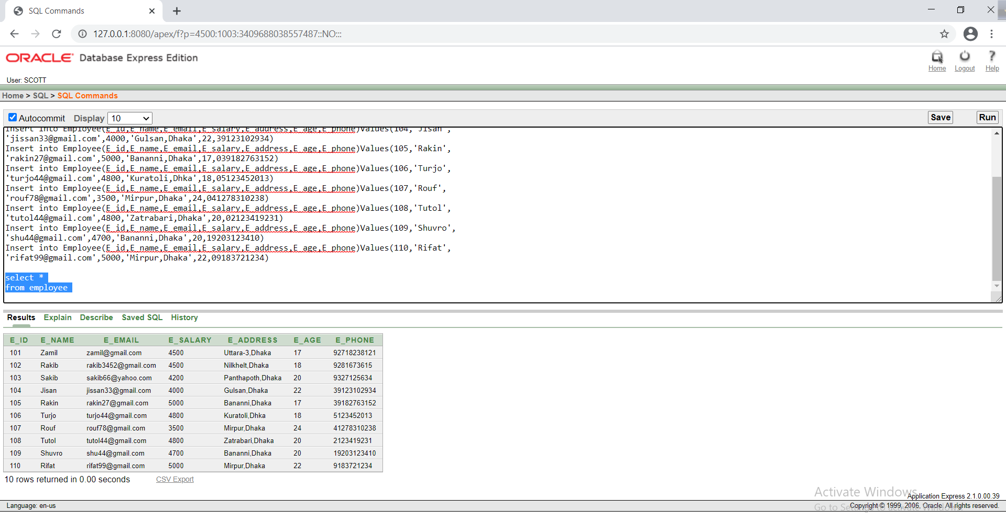

For Tickets Table:

Insert into Tickets(T_id,T_name,T_price)values(0001,'General',320)

Insert into Tickets(T_id,T_name,T_price)values(0002,'VIP',500)

Insert into Tickets(T_id,T_name,T_price)values(0003,'PREMIUM',400)

Insert into Tickets(T_id,T_name,T_price)values(0004,'General',320)

Insert into Tickets(T_id,T_name,T_price)values(0005,'PREMIUM',400)

Insert into Tickets(T_id,T_name,T_price)values(0006,'General',320)

Insert into Tickets(T_id,T_name,T_price)values(0007,'VIP',500)

Insert into Tickets(T_id,T_name,T_price)values(0008,'PREMIUM',400)

Insert into Tickets(T_id,T_name,T_price)values(0009,'PREMIUM',400)

Insert into Tickets(T_id,T_name,T_price)values(0010,'VIP',500)

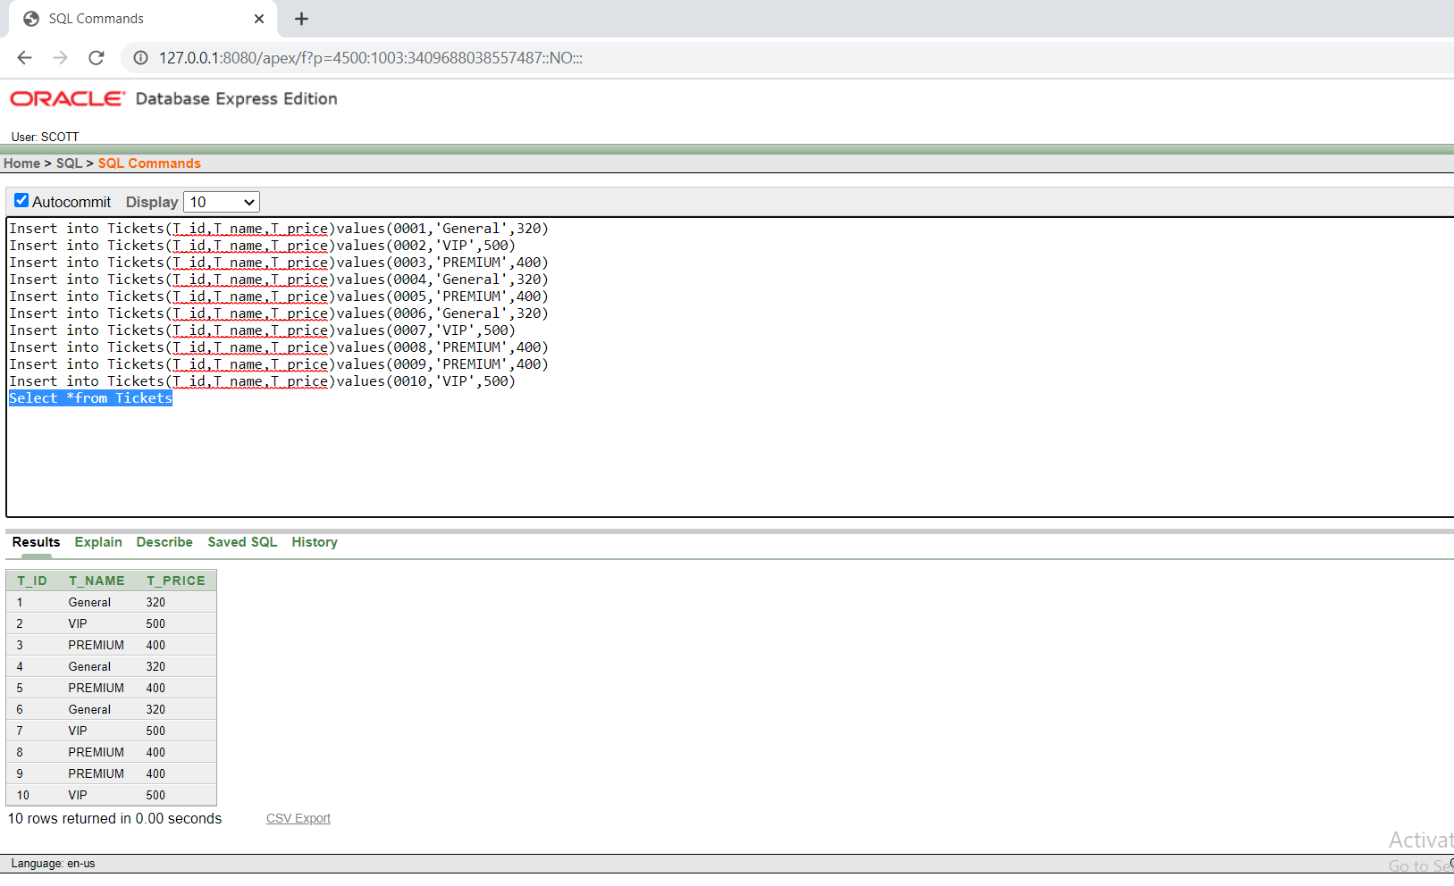

SHOW TABLE

Insert into Shows(S_ID,S_Name,Start_time,End_time)Values(01,'Movie 1','9 am','10 am')

Insert into Shows(S_ID,S_Name,Start_time,End_time)Values(02,'Movie 2','10 am','11 am')

Insert into Shows(S_ID,S_Name,Start_time,End_time)Values(03,'Movie 3','11 am','12 pm')

Insert into Shows(S_ID,S_Name,Start_time,End_time)Values(04,'Movie 4','12 pm','1 pm')

Insert into Shows(S_ID,S_Name,Start_time,End_time)Values(05,'Movie 5','1 pm','2 pm')

Insert into Shows(S_ID,S_Name,Start_time,End_time)Values(06,'Movie 1','3 pm','4 pm')

Insert into Shows(S_ID,S_Name,Start_time,End_time)Values(07,'Movie 3','4 pm','5 pm')

Insert into Shows(S_ID,S_Name,Start_time,End_time)Values(08,'Movie 4','5 pm','6 pm')

Insert into Shows(S_ID,S_Name,Start_time,End_time)Values(09,'Movie 2','6 pm','7 pm')

Insert into Shows(S_ID,S_Name,Start_time,End_time)Values(10,'Movie 5','7 pm','8 pm')

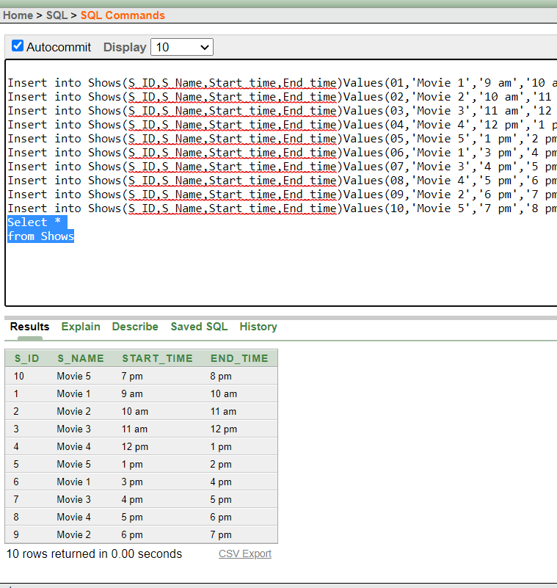

Insert into Ticket_show(T_id,T_name,T_price,S_id)Values(0001,'General',320,01)

Insert into Ticket_show(T_id,T_name,T_price,S_id)Values(0002,'VIP',500,02)

Insert into Ticket_show(T_id,T_name,T_price,S_id)Values(0003,'PREMIUM',400,03)

Insert into Ticket_show(T_id,T_name,T_price,S_id)Values(0004,'General',320,04)

Insert into Ticket_show(T_id,T_name,T_price,S_id)Values(0005,'PREMIUM',400,05)

Insert into Ticket_show(T_id,T_name,T_price,S_id)Values(0006,'General',320,06)

Insert into Ticket_show(T_id,T_name,T_price,S_id)Values(0007,'VIP',500,07)

Insert into Ticket_show(T_id,T_name,T_price,S_id)Values(0008,'PREMIUM',400,08)

Insert into Ticket_show(T_id,T_name,T_price,S_id)Values(0009,'PREMIUM',400,09)

Insert into Ticket_show(T_id,T_name,T_price,S_id)Values(0010,'VIP',500,10)

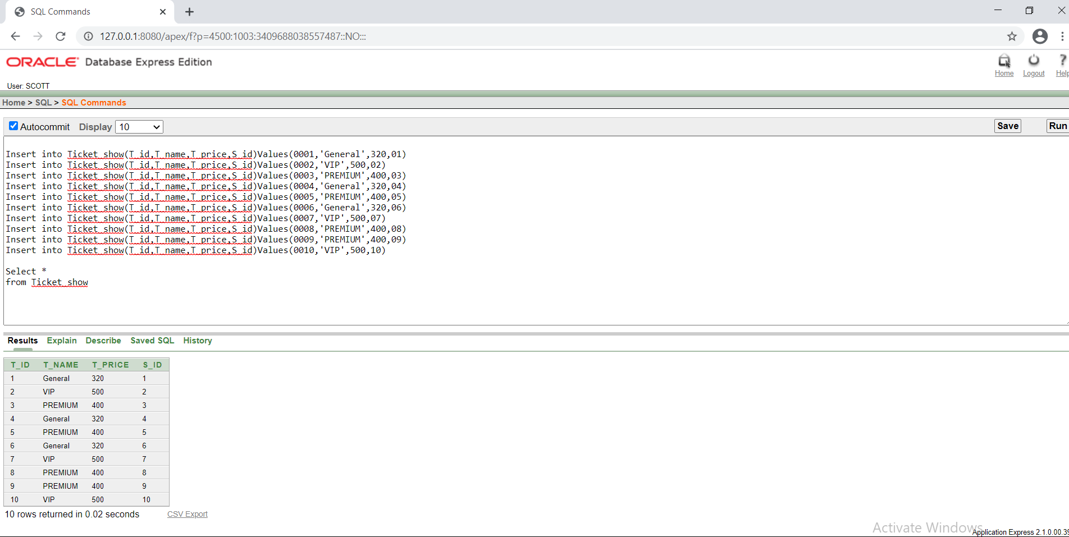

1.Write a query to display Ticket name where ticket id is greater than 5. (Tickets table)

Select T_name from Tickets where T_Id > (Select T_Id from Tickets where T_Id=5)

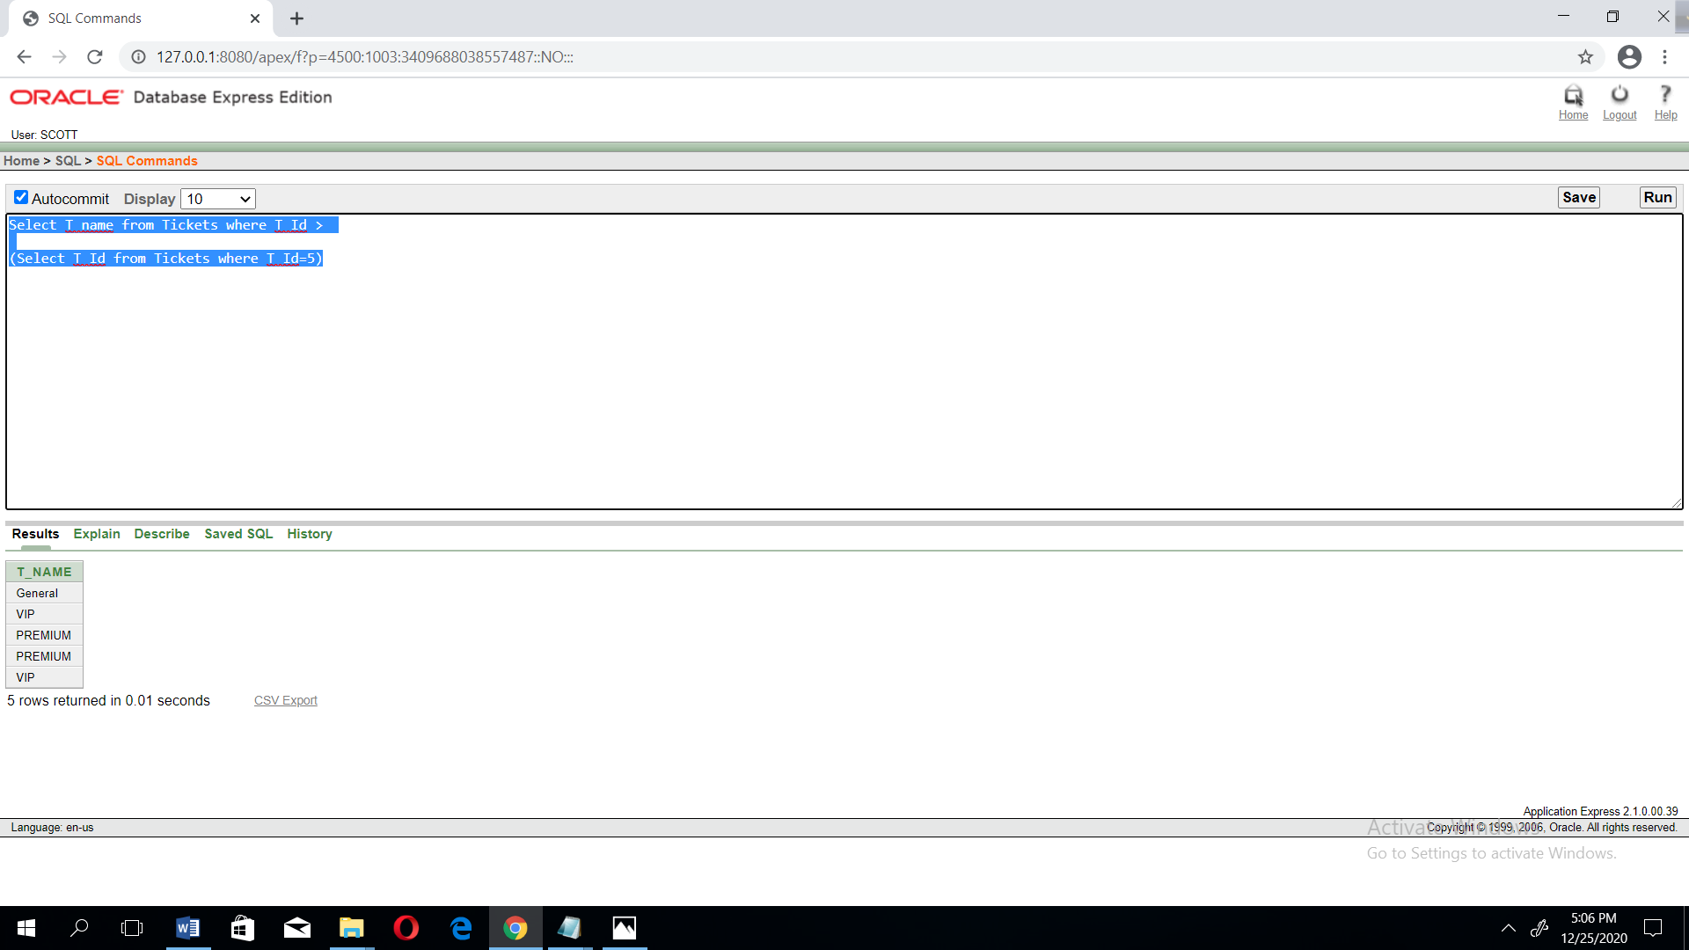

2. Write a query to display the Ticket id, Ticket name and Ticket price for all Tickets whose price more or equal than the average price. (Tickets table)

Select T_ID,T_NAME,T_Price from Tickets where T_price >= (select avg(T_price) from Tickets)

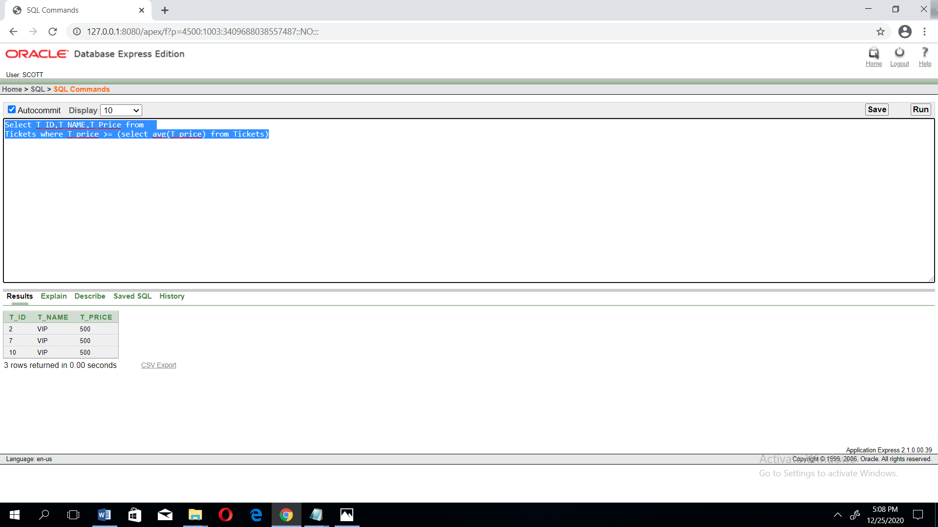

3.Write a query to display Employees name,salary and age who get the age wise lowest salary.(Employee Table)

Select E_name,E_salary,E_Age from employee where E_salary in(Select min(E_Salary) from employee group by E_Age )

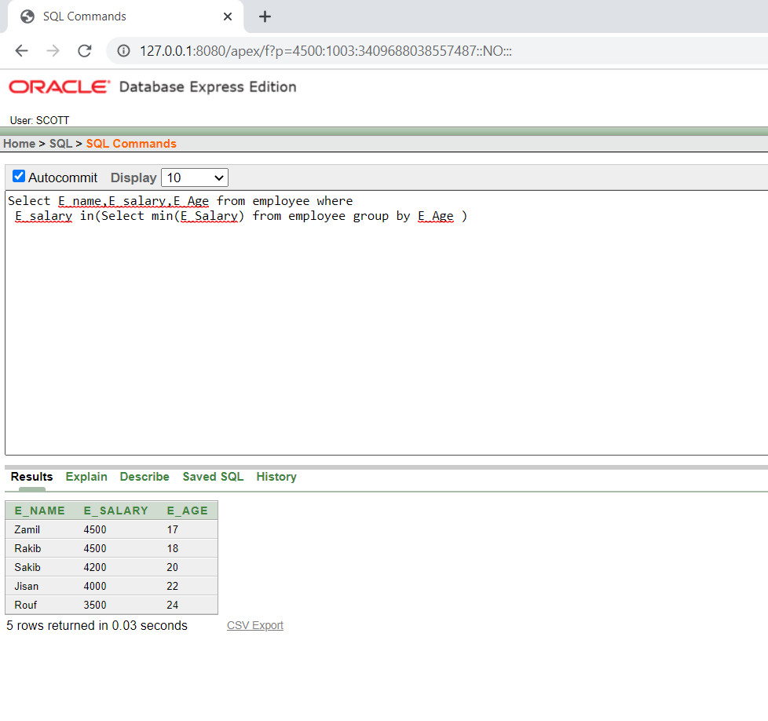

4.Write a query to display average, maximum, minimum and sum of all employees salary.(employee table

Select avg(E_salary),max(E_salary),min(E_salary),sum(E_salary) from employee

